DML Commands with Constraints – UPDATE, DELETE
Aim:
To perform Data Manipulation Language (DML) Commands such as UPDATE, DELETE in the table.

Description:
Data Manipulation Language (DML) statements are used for managing data within schema objects. DML commands:
➢ UPDATE - update existing data within a table
➢ DELETE - deletes all records from a table, for the records remain

UPDATE:
UPDATE table_name
SET column1=value, column2=value2
WHERE some_column=some_value;
DELETE:
DELETE FROM table_name
WHERE some_column=some_value;
Questions:
1. Update the juice name of the customer whose token number is 321 to Orange.
2. Delete the record of the customer whose token number is 322.
3. Modify the number of juices purchased by the customer Rani to 5.
4. Remove all customer records where the number of juices is less than 2.

QUESTION – 1
STEP 1:Execute UPDATE
UPDATE juiceshopc
SET juice_name = 'Orange'
WHERE token_no = 321;

STEP 2: Verify the update
SELECT * FROM juiceshopc
WHERE token_no = 321;

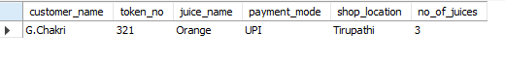

Question 2
Delete the record of the customer whose token number is 322.
The customer with token 322 is Raju.
Step 1 — Execute DELETE
DELETE FROM juiceshopc
WHERE token_no = 322;
Step 2 — Verify the deletion
SELECT * FROM juiceshopc;
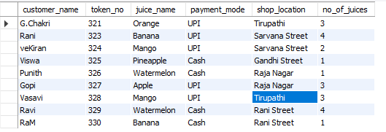
The Raju / 322 record should no longer appear.

Question 4
Modify the number of juices purchased by the customer Rani to 5.
Step 1 — Execute UPDATE
UPDATE juiceshopc
SET no_of_juices = 5
WHERE customer_name = 'Rani';

Step 8 — Verify
SELECT * FROM juiceshopc
WHERE customer_name = 'Rani';
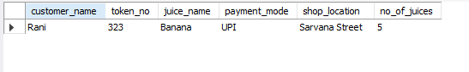
So 4 → 5 juices.
Question 4

Remove all customer records where the number of juices is less than 2.
Step 1 — Execute DELETE

DELETE FROM juiceshopc
WHERE no_of_juices < 2;

This will delete records where no_of_juices is 1.
In your original data, these are:
- Raju — token 322 — already deleted in Question 2
- Viswa — token 325 — 1
- Punith — token 326 — 1
- RaM — token 330 — 1
Because Raju was already deleted, this command will remove the remaining records with 1 juice.

Step 10 — Display the final table
SELECT * FROM juiceshopc;
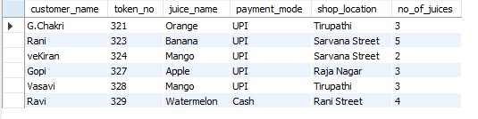
RESULT
The UPDATE and DELETE commands were successfully performed on the juiceshopc table. The required customer records were updated and deleted, and the final records were verified using the SELECT command. This matches the purpose of Experiment 4 in your lab manual.

